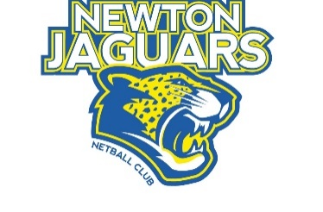
Newton Jaguars Netball Club
ABN 96 945 337 805
P.O. Box 76 Campbelltown
SA 5074

NEWTON JAGUARS NETBALL CLUB INC

TEAM SPONSORSHIP PROPOSAL

Thank you for your interest in being involved with the Newton Jaguars Netball Club as an AMND Team Sponsor of

…….………………………………………………….
Name of Team

SPONSOR ENTITLEMENTS

As a sponsor of a NJNC AMND Team you are entitled to the following:
(Please tick the entitlements you wish to receive and add any variations for approval)

- Business Logo/Name on Warm up tops of team sponsored
- Sponsor acknowledgement on the Clubs Promotional material and signage
- Business website linked to Club website
- Invitation to Premier League Game (2 tickets)
- Team framed photograph or Plaque of Appreciation
- Membership of NJNC
- Participation in Club Loyalty program
………………………………………………………………………………………………..

SPONSORSHIP COST

- Team sponsorship fee 2022 $ 1000 (plus GST)

Upon acceptance of this proposal an invoice will be sent to you requesting payment for this amount. Payment terms are 30 days. Any sponsorship questions can be directed to secretary@newtonjaguars.com.au.

SPONSOR DETAILS

Business Name: ……………………………………………………………………………………………..
Contact Person: ……………………………………………………………………………………………..
Postal Address: ……………………………………………………………………………………………..
………………………………………………. Post Code: ……………………………
Mobile Contact: ……………………………………………………………………………………………..
Email Address: ……………………………………………………………………………………………..

NOTE: Please provide a PDF copy of company logo at time of signing sponsorship agreement.

